PLEASE SAVE WATER

As you all know, the state of Georgia is experiencing a severe drought. It is every citizen’s responsibility to collaborate to help us get through this problem.

During this time, we ask that you please refrain from
washing both your hands. Only wash the left or right one if you feel you really need to.

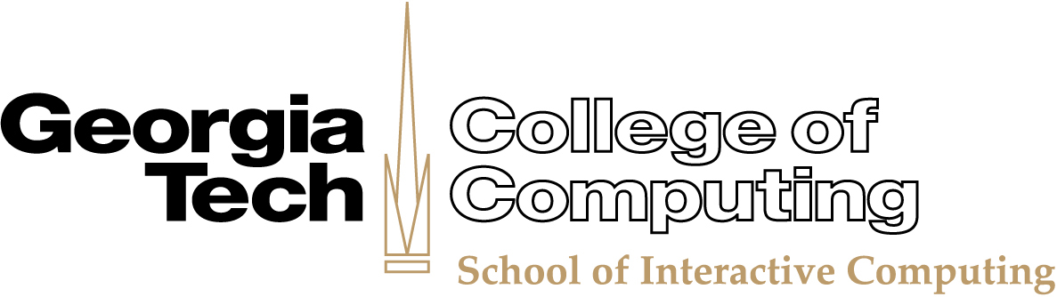
Thank you
The MGMT

