
Traffic and Transport Services

Official Recreational Guide to

Hurst Road Lamorbey Baths Bus Stop

Lat. 51° 26.1’ North - Long. 0° 6.3 East

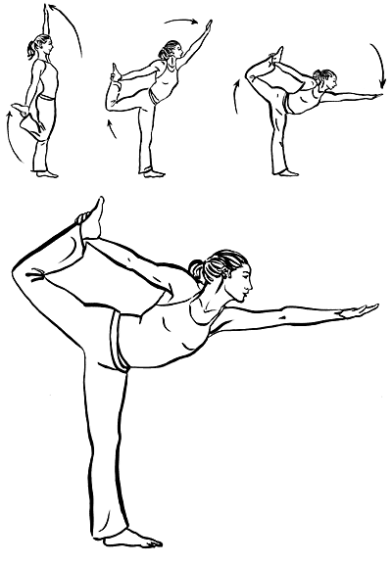
Your local council, in association with SF0’s Greater London Rapid Transit Psychogeographical Association, has started this new campaign to ensure our loyal customers enjoy not only our clean, efficient, and always-reliable buses, but also your valuable time spent waiting. We hope our customers will appreciate this recreational guide and deepen their appreciation of this bus stop, and bus stops everywhere.

Our empirical research shows that bus rides over 10 minutes can cause cramps and undue muscle tension unless proper stretches and warm-up exercises are performed up to 2 minutes before boarding. The quickest and easiest all-body stretches can be found in yoga, particularly the Dancing Shiva (fig 1). Please be careful when practicing this maneuver, gradually increasing the range until you can execute it in one fluid movement. If you perform this exercise facing Hurst Road at 11 o’clock, you can also function as a human pointer to the famous 9-hole Sidcup Golf Course, established in 1926.

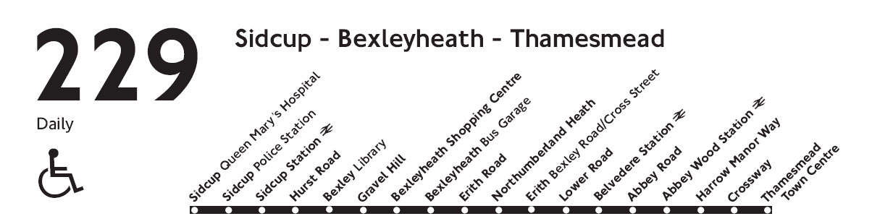
At this point, you might want to make sure that you are indeed waiting at the correct bus stop. This particular stop is exclusively for the 229 Bus heading towards Sidcup Queen Mary’s Hospital. If you are attempting to head in the opposite direction, towards the Bexleyheath Shopping Centre and Thamesmead Town Centre than please locate the bus stop across the street and 50 feet to the left.

Fig. 1

If you are indeed at the correct bus stop, than perhaps you would like to become better acquainted with it. This particular bus stop is 14 x 2.5 feet, with a rain cover standing 8.5 feet tall. It features a small metal bench where customers, perhaps you yourself, can rest before the bus arrives (have you done your exercise yet?). We hope in the future to outfit this stop with better protection from the wind, as we are aware it is very susceptible to cold wind. Also, we will be installing name placards in order to ‘personalize’ the stops. This particular stop will be -
The only time you run out of chances is when you (bus) stop taking them bus.”

We hope this quote will inspire our customers no matter where their journey takes them.

We leave you with some thoughts left to us by your fellow travelers.

“This bus stop is like a ripe tempranillo, light and early. It plays across the palate like a morning sunrise.”

“This bus stop foreshadows a happy journey and a safe return. I also enjoy the use of colloquialisms.”

“I counted all xx windows you can see from this stop while waiting once. It was a stellar day.”

This bus stop has been rated ♦♦♦♦ out of ♦♦♦♦♦. If you are interested in this campaign, please enquire online.

