Urawaza: “Show someone a better way to solve mundane problems,” or---
Finding Creative Solutions for Mundane Problems

Finding good solutions to mundane problems is not so much a matter of showing someone what to do but, rather, showing them ways to use imagination. Instead of conjuring up tutorials that are as boring as the problem, itself, why not peek into “The Secret Life of Walter Mitty.” In other words, why not look for ways to turn the mundane into the exhilarating. Here are two examples.

Several weeks ago I stumbled into a convention a dozen wasps were holding on the branches of the bogan villa in our back yard. Two of them stung me and several others drove me into the house. The effective, but mundane, solution was to call an exterminator. Those professionals eliminated the problem, but the incident left me feeling well, cowardly. The more I reflected the more I began to understand that it would be much more fulfilling, and fun, to tune in with Walter Mitty. The next time I encounter a wasp convention I will don my winter Nebraska clothes, complete with ski mask, and return with a can of Raid. When the little devils bear down me, I will see them not as mere insects, but as enemy fighter jets. To save the village, I will shoot them down, one by one, and then swagger into the house for a glass of wine.

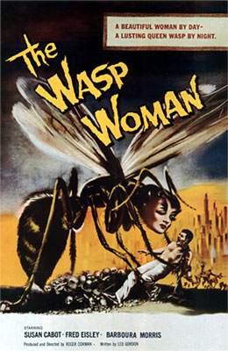

Painting walls is a truly mind-numbing experience. Tom Sawyer escaped it by duping others into doing the job. My solution would not involve tricking others, but rather tricking one’s self. Consider the Olympic sport of Curling. On the surface, what could me more boring than ice skaters sweeping a disk into a circle. Add 5,000 cheering spectators, however, it suddenly takes on at least the aura of excitement. While it wouldn’t be possible to squeeze 5,000 people into your living room, painting could become much more interesting if it became a contest. Two painters square off on separate walls in a quest to gain the most points for quickness, neatness, and of course points for creating the most enticing ambiance. We could be talking Olympics here!

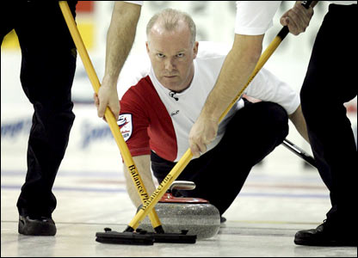 With a little tweaking, wall painting could be just as exciting

