Going To The Highest Point
(Well, not really the highest point, but high enough for me.)

Long’s Peak, one of the 14,000 foot mountains in Colorado, will capture and hold your imagination long after you’ve first seen it. It is the mountain with the broad, flat summit where an Arapahoe medicine man once trapped eagles. It is the mountain with a sheer wall that rises 1,700 feet above an ancient lake. Joy and I had dreamed of climbing this mountain all winter. Finally, we would get the chance to try and do it.

Until we reached the Keyhole, the climb was nothing more than an uphill hike. At a distance, the boulder field seemed to flow up gradually into the saddle of the Keyhole. But as we got closer, we soon discovered it was steep enough to require full deployment of all limbs and digits.

“This will probably be the worst part,” I told her as we rested 10 feet below the saddle. I was wrong.

First there was the howling wind that nearly blew us back down as we pulled ourselves up over the edge. But that was minor compared to what he found on the other side, which was basically nothing straight down to the tundra 300 feet below. At that point, Joy had had enough. She kissed me on the cheek and told me to be careful
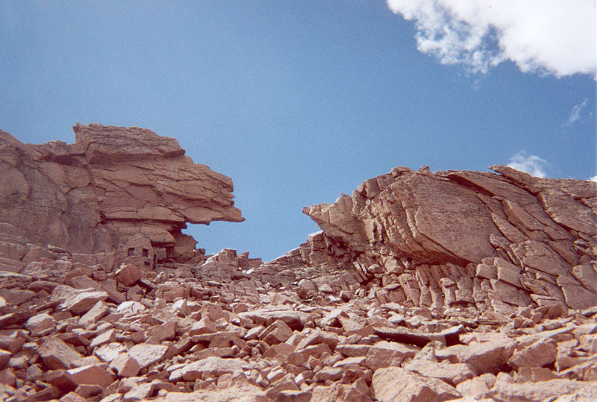 The Keyhole
The trail leading out of the Keyhole was fairly wide for the first 400 yards. It seemed safe and I felt my confidence grow with every step until I climbed into a slab of rock wedged in the side of the mountain. The trail ahead, which had now narrowed to 2 feet, curved out of sight to the east and I could no longer see a slope below it. I was now sitting on a 2-foot ledge, halfway between Heaven and Hell, where my dream of standing on the summit had suddenly collided with my fear of falling. As I sat there, I tried to forget the abyss just off the narrow ledge and envision what the summit must be like; the panorama of mountains lakes and maybe even a red-tail hawk soaring in lazy gyres two thousand below. Had the heavens not interceded, my vision might have goaded me around the bend and perhaps over the edge.

As I was edging back on the trail, I bumped my camera and dislodged the lens cap. The cap fell to the ledge and then bounced over the side. After what seemed like five minutes of total silence, I heard: tick, tick, tick, the unmistakable sound of plastic striking granite. No doubt about it, God was telling me to go back. And so, I did.

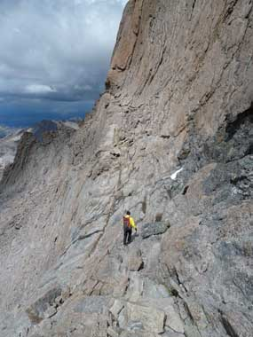 Should I go or should I stay?

